“Openrecrute” – Web based recruitment management system

A.L.K.R.Goonesekere
Index number: 1029398

Client: Openarc

Name(s) of the supervisor(s):
Mr. Anuruddha Ranatunga
Mr. Dinesh Rodrigo

Academic Year 2012/2013
Date: 25-04-2013

Declaration
I certify that this dissertation does not incorporate, without acknowledgement, any material previously submitted for a Degree or Diploma in any University and to the best of my knowledges and belief, it does not contain any material previously published or written by another person or myself except where due reference is made in the text. I also hereby give consent for my dissertation, if accepted, to be made available for photocopying and for inter-library loans, and for the title and summary to be made available to outside organizations.

………………………….. Date: ……………………..
A.L.K.R.Goonesekere

Countersigned by:

…………………………. Date: ……………………..
Mr. Anuruddha Ranatunga

…………………………. Date: …………………….
Mr. Dinesh Rodrigo

Abstract

OpenArc School of Business & Technology Ltd, is a Leading training school which was set-up in September 1995 by OpenArc Systems Management with a genuine objective of promoting local talents in IT and producing skilled people for the IT industry.

During past few years, Hotel Chance palace marker has been increasing continuously. Due to manual event management, Chance Palace management has faced lot of inconvenience and scheduling conflicts. Thereby the management of the hotel Chance Palace has decided to develop and implement a web based event management system to overcome most of these problems and enhance their efficiency.

Rheostat is basically developed to manage the regular management procedures of events carried out within the Hotel Chance Palace. This system is capable of User Registration, Managing Events, get information about available events, send Emails to customers, Managing Invoices and View/Manage event report status. For each and every person within the system have their own username and password to access the system.

Since this is a web based system, speed of the system is a very important fact. Because of the easiness of the implementation and speed, a structured methodology is used to develop the system.

System is developed based of open source technologies. PHP is the main programming language used to develop the system. Also Object Oriented Concepts are also included into PHP to develop the system. MySQL is used as the database management system. Apache web server is used as the processing server.

Few open source libraries were used to enhance the systems features and activates such as pagination and search. Sending Email notifications to the customers as well as Administrator is a unique feature in this system. This will be considered as the research and development (R&D) part of this project.
Acknowledgement

In first place I would like to thank the staff of UCSC including director, BIT coordinator and the academic staff for creating such a great programme, that students can learn much and have a good exposure in Information Technology.

Secondly, to my project supervisors Mr. Anuruddha Ranatunga and Miss. Dinelka Jayakody for being very much supportive throughout the project and all guidance they had given to me.
Thirdly, my client, Hotel Chance Palace including the Chairman – Mr. Bandula Sirikumara, the Manager Mr. Sachintha Udara Sirikumara and the Receptionist Mr. Weerasinghe, who are very busy persons but allocate all time they could give me for a discussion regarding the project. Also they very supportive and kindly gave all the details that I wanted to know about the business and clarify the process.

I would always gratefully like to remember and thank my parents for being very much supportive and patient with me working on late time in every moment that I’m at home.

Finally all my teachers & friends @ class, elder brothers and sisters @ the office, who guided me, taught me new things and techniques which sometimes I never thought that I could easily learn.

Table of Contents

ABSTRACT iii
ACKNOWLEDGEMENT iv

CHAPTER 1 – INTRODUCTION
1.1. BACKGROUND 1
1.2. MOTIVATION FOR THE PROJECT 2
1.3. OBJECTIVES OF THE PROJECT 3

CHAPTER 2 – ANALYSIS
2.1. INTRODUCTION 5
2.2. CURRENT STATUS 5
2.3. REQUIREMENT ANALYSIS 6
2.4. FUNCTIONAL AREAS OF THE SYSTEM 9
2.4.1. USER REGISTRATION 9
2.4.2. CREATE EVENTS 10
2.4.3. MANAGE/VIEW EVENT SEDULES 10
2.4.4 MANAGE/VIEW INVOICES 10
2.4.5. MANAGE/VIEW REPORTS 11
2.4.6. RECEIVE EMAIL NOTIFICATIONS 11
2.4.7. MANAGE REFERENCE DATA 11
2.4.8.MANAGE FINANCIAL DATA 11
2.5. NON-FUNCTIONAL REQUIREMENTS 11

CHAPTER 3 – DESIGN OF SOLUTION
3.1. ALTERNATIVE SOLUTIONS 13
3.2. JUSTIFICATION OF THE SELECTED SYSTEM 13
3.3. DESIGN APPROACH 14
3.3.1. ENTITY RELATIONSHIP DIAGRAM (ERD) 14
3.3.2. DATA FLOW DIAGRAM (DFD) 15
3.3.3. CLASS DIAGRAM 17
3.3.4. STATE DIAGRAM 18

REFERENCE 19

Chapter 1 – Introduction

With the technology growing day by day, it is becoming a part of our everyday life. Computer software is used anywhere to make tasks easy. Open Source technology is a great improvement in computer software field where we can deliver solutions with less cost. Along with open source technology web based architecture is getting much popular because of the ability to deliver a single solution to a wide audience regardless of the environment of the end user. Rheostat is web based event management system using above two features to cater users, managers, and administration staff with cost effective, efficient, reliable and informative way.

1.1 Background

Chance palace is one of the leading Hotels in the Gampaha Area. They had started their initial in the early 99’s with vision of being the best Hotel and Banquet Industry is Gampaha area. Mr. Bandula Sirikumara current (CEO) identifies the potential in Hotel Industry in Gampaha area. As a results of that he initially started Hotel Chance with provides banquet hall and facilities at his house with the help of less 8 members.

In year 2005 Hotel Chance Palace As a results of that they set up Hotel Chance palace which is located 3KM away from veyagoda. Today, hotel chance offers employment to around 40 direct and indirect people. Chance palace belongs to sole proprietor business type which is owned by and run by Mr. Bandula Sirikumara. Hotel Chance Palace mainly consists of two attractive banquet halls and 10 rooms with calm and quiet environment which makes it an ideal place for functions along with outstanding features and services.

Chance Palace enables their customer to make use of the below service.
- Make reservations for special occasions such as weddings, home comings, parties and conference.
- Make room reservation for wedding couples.
- Allow for outdoor catering services.
Chance palace has been widely recognized for mid-range wedding hall reservations. As indicated by Sirikumara Approximately 80% of their income has been gaining through wedding hall reservations. Rest of the 20% gained through room reservation and catering service.

1.2 Motivation for the Project

Hotel and Banquet industry is one of the most expanding businesses in Sri Lanka. Hotel Chance Palace is a leading banquet hall which is located at Gampaha, Sri Lanka. During past few years, their market has been increasing continuously. Due to manual event management, Chance Palace management has faced a lot of inconveniences and scheduling conflicts. The Management has decided to develop and implement a web-based event management system to overcome most of these problems and enhance their efficiency.
Problems are as follows:
- The client currently uses a manual event management system.
- The above mentioned manual system is not managed properly, thus the client does not reap the benefits of the manual system.
- The client has to maintain a large number of books to keep their customer records.
- Since they are maintaining separate books to store customer data & event data for each banquet hall there is a high possibility of feeding the details about an event in a different book
- Security issues of data (eg: exposing confidential information, books can be misplaced, Possibility of missing certain data, etc…).
- Data redundancy.
- Data inconsistency.
- In case the customer needs certain changes in his order it will be a tiring job to make those required changes in different locations.
- Difficulty of handling & manipulating a large amount of data in books.
- Difficult to produce much needed MIS reports as it is a time consuming process to extract data from various books and present them in one report.
- With the current manual system, the client is unable to accurately calculate the profit per bill.

1.3 Objectives of the Project

By using the new system many advantages can be gained to receptionist and the administration staff. Accurate and updated information will be always available over the web based portal for everyone. System will facilitate to maintain a database of events information by creating them. Therefore, it’ll be lot easier to track its’ history. Receptionist will be able to log in to his account and create an event, cancel previous event and view its’ report status etc…. Bothe Administration staff and Managers will able to see what events created for a particular day, week, month and year and accept payments and insert it into the system and update payments details and see a list of delayed payments. Both administration staff and customers will receive Email notifications for delayed payments. Therefore telephoning each and every one is not necessary to inform.
- Arrange current storage system (File based) into DBMS.
- Reduce data duplication.
- Ensure the security and integrity of data and information by providing user privileges to appropriate user and by implementing controls.
- Minimize the possible errors, which arise when handling day to day events manually.
- Make creating events, editing existing events and remove certain events much easier.
- Generate reports easily according to management requirements.
- Increasing productivity and customer satisfaction through the system.
- To increase efficiency within the client organization by reducing time taken for manual documentation and processing.
- To apply the knowledge and experience the author gained through the BIT degree program.

Chapter 2 – Analysis

2.1 Introduction

Chance palace is one of the leading hotels in the Gampaha area. They had started their initial in the early 99’s with vision of being the best Hotel and Banquet Industry in Gampaha area. Hotel Chance Palace mainly consists of two attractive banquet halls and 10 rooms with calm and quiet environment which makes it an ideal place for functions along with outstanding features and services. Chance Palace enables their customer to make reservations for special occasions such as weddings, home comings, parties and conferences. Allow to make room reservation for wedding couples and allow for outdoor catering services. Chance Palace has been widely recognized for mid-range wedding hall reservations. As indicated by CEO approximately 80% of their income has been gaining through wedding hall reservations.

Mostly the services and the prices of Chance Palace are fixed for to suites the income level of middle income people. Therefore customers could find much cheaper prices at Chance Palace compared to other competitors.

2.2 Current Status

At the moment, Hotel Chance Palace does not use any kind of computerized system to create events, maintain event schedules, and maintain report details, managing customers and system users. All the above tasks are processes using traditional book keeping methods where lot of time and other resources are wasted.

The above mentioned manual system is not managed properly, thus the client does not reap the benefits of the manual system. Also the client has to maintain a large number of books to keep their customer records. So it is more time consuming process. In the case the customer needs a certain changes in his reservation it will be a tiring job to make those required changes in different locations.
Rheostat is a web base event management system which is developed to address above issues with the current procedure. Following details will elaborate core of the system and its functionality.

2.3 Requirement Analysis

The whole system is designed with three subsystems; Registration system, Event management system and Manage reports and invoices system. Illustration of the system’s intended functions, its surroundings and the relationship between them are provided using use case diagrams. These three main use cases represent the functionality provided by the system. Receptionist, manager and administrator are the main actors of the system.

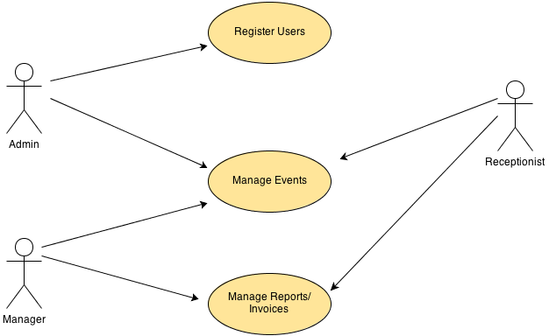

Figure 2.1 – Main Use Case diagram of the Event Management System

The above main use case diagram is illustrated using three use case diagram. In order to get clear idea, use case descriptions were written for the main use cases. Further brief description about the Actors of the system was given below.

Actors of the System

A brief description of actors of the system;
1. Admin: A person who carried out all administrator works.
2. Manager: A person who responsible to maintain communication gap between administrators and reception.
3. Receptionist: A person who is managing the event and all other activities.

2.3.1 Registration System

Figure 2.2 provide the use case diagram for the Registration System. The main actor of the system is Admin. First system should verify whether the admin logged in, if not admin can log in by providing the accurate credentials. Then the admin can create new users for the system or update existing user details.
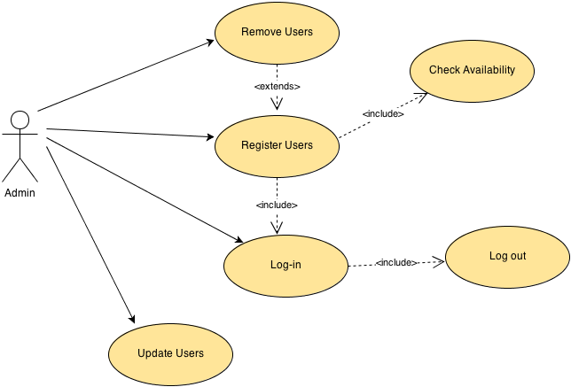

Figure 2.2 – Use Case diagram for the Registration System

2.3.2 Manage Events System
Figure 2.3 shows the use case diagram for the Manage Event system. The main actors of the system are the Manager and the Receptionist. Initially the system should verify, if the particular user has logged in. If it is not, user can log into the system by providing the accurate credentials.

After the particular user has logged into the system they can create new events or edit existing event or delete event in the system. When create a new event, system should validate the event details by referring the event schedules to verify whether the new event can be create or not. If it does not allow creating it system should display an error message. If there are no any errors it will allow creating that event. Same process will be used for the Update function and Delete function.

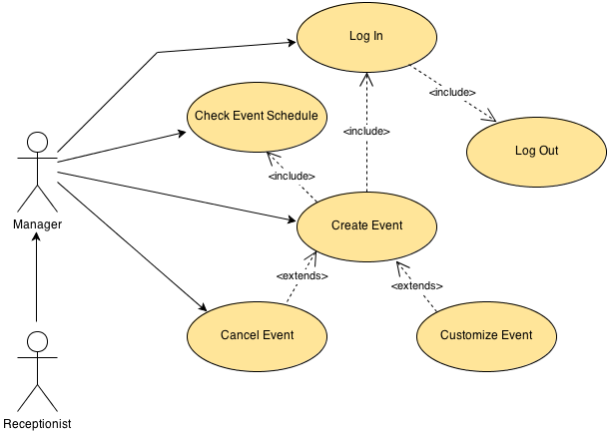

Figure 2.2 – Use Case Diagram for Manage Events

2.3.3 Manage Reports/Invoices System

Figure 2.3 illustrate the Use Case diagram for the system of Manage Reports/Invoices System. The main actors are the Admin, Manager and the Receptionist. First system should verify whether a particular user has logged into the system or not. If it is not, user can log into the system by providing the accurate credentials.

After successfully logged in user can carry out their processes. Any user can generate various kinds of reports according to their choices. Also any user can accept payment and inset data into the system and generate invoices. But the update process of payments details is allowed to do only the authorised users (Admin or Manager). So the system should validate user in the process of update payments details.
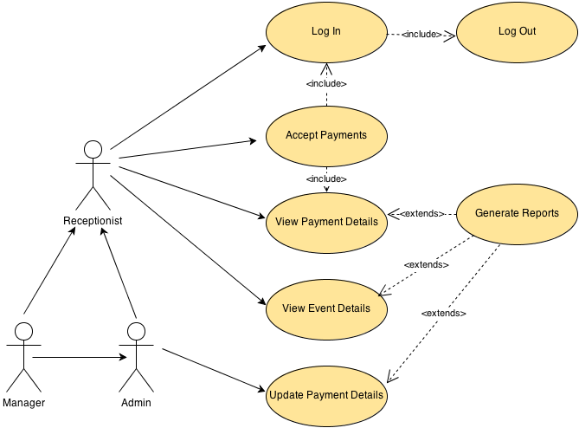

Figure 2.3 – Use Case Diagram for Manager Reports/Invoices System

2.4 Functional Areas of the System.

2.4.1 User Registration

Each and every user can be registered in the system using a unique username and password. There are 3 types of users and they are the Receptionist, Manager and the Administrator. When registrations are completed by providing required details, users can be log-in to the system and do their stuffs.

2.4.2 Create Events

This can be done by the Receptionist and the Manager. The user can create new events according to their calendar dates. When creating a new event, user must be logged into the system. After successfully logged in, the user has to check the event schedule. If the new event can be create on the required date in the required time user will create a new event. Otherwise system will reject the creation of the event notifying that with the error message. Then the user can re-schedule the new event with new date and time according to the customer requirements.

2.4.3 Manage/View events schedules

Receptionist and Manager can manage the event schedules and other details using a provided interface in the system. These changes can be viewed by any user who has registered in the Rheostat system.

2.4.4 Mange/View invoices

After successfully creating an event system has to allow generating invoices relating to a particular event. This can be done by the Receptionist and Manager. They can create new invoices for the new events and also can manage previously created invoices by updating, deleting or doing some other modifications according to the customer requirements. These invoices will be provided to the customers at the end of the process including the full amount for his/her event.

2.4.5 Manage/View reports

This can be done by the Manager and the Administrator of the Rheostat system. These users can generate reports to get the overall progress of the business. Also they can get the proper idea about their financial stability through these reports. They can also be able to get more accurate decisions by seeing reports which help to develop their business rapidly.

2.4.6 Receive Email notification

Email notifications will be sent to the customers if there any delaying payment. The notification including the date the customer has made the advance payment, amount customer paid, due date & the due amount.

2.4.7 Manage Reference data

Administrator can manage reference data from an interface provided in the back end. Reference data includes user types, event types, event details, price details etc....

2.4.8 Manage/View financial data

Receptionist, Manager and Administrator allow to manage financial data of the business. All the users can enter the financial data into the system. But only the Manger and Administrator is allowed to update those financial data. These financial data including the customer payments, advance payments, delay payments etc......

2.5 Non-Functional Requirements

In systems engineering and requirements engineering, a non-functional requirements is a requirement that specific criteria that can be used to judge the operation of a system, rather than specific behaviours [WWW1].

Availability –
This system is developed as a web based system and will be hosted on a USA based web server which guaranteed 99.9% uptime. This system will be available for the users who are working as authorized persons of the Hotel Chance Palace. System can be accessed 24 hours per day and 7 days per week without any problem.

Usability –
System will be developed especially to address the issues in the current procedure of the Hotel Chance Palace. System will be focused and optimized to use which will not affect both administration and non-administration users.

Security –
Each and every action in the system other than viewing event schedules is controlled using user login.

Efficiency –
System is developed using PHP script language. All the queries runs in the system are optimized to get optimal performance and speed even in a law bandwidth internet connection.

Chapter 3 – Design of Solution
This chapter describe what options are considered before developing the system, methodologies that can be used to develop the system, structure of the system, user interfaces and the database structure of the system.

3.1 Alternative Solutions
Few alternative solutions were considered before developing the system. They are listed below.

- Alternative 1 – Customize an open source event management system to suite the requirement of the client.

- Alternative 2 – Purchasing a commercial event management system and customized it to suite the client’s requirements.

- Alternative 3 – Developed and implement a system based on Microsoft’s .Net platform.

- Alternative 4 – Develop and implement a LAMP/WAMP based solution.

3.2. Justification of the Selected System

Since the client is considered about the development cost of the system and the hosting cost which he has to pay annually. Therefore alternative 2 and alternative 3 cannot be used to fulfil the client’s requirements as alternative 2 will spend lot of money to purchase a commercial application and alternative 3 will also spend lot of money to use .Net framework.

Since the developer is also very much familiar with developing applications with PHP and MySQL and hosting charges for PHP and MySQL based software is very low, alternative 4 seems to be suitable for fulfilling client’s requirements. Therefore considering those facts, developing a LAMP/WAMP based system is chosen.

3.3. Design Approach

This system will be developed using an Object Oriented Programing and Techniques. PHP is the development language of this project. Unlike other programing languages, PHP offers either objects oriented methods or procedural method to develop a system. Since the system is web based and PHP is scripting language it will be most suitable to use the object oriented method to develop the system. Also it will be an advantage for the reusability of the code segments.

3.3.1 Entity Relationship Diagram (ERD)

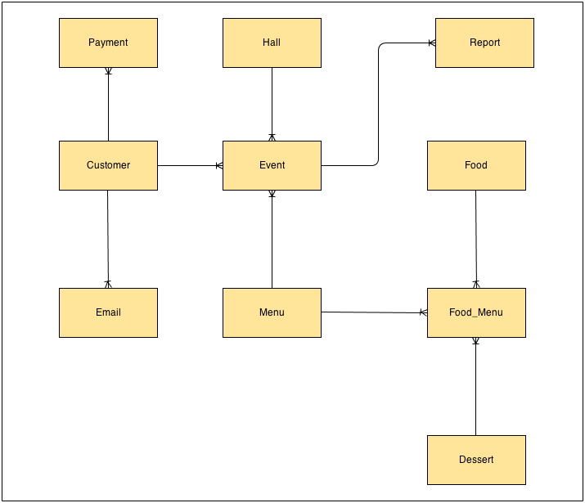

Figure 3.1 – Entity Relationship Diagram

3.3.2 Data Flow Diagram (DFD)
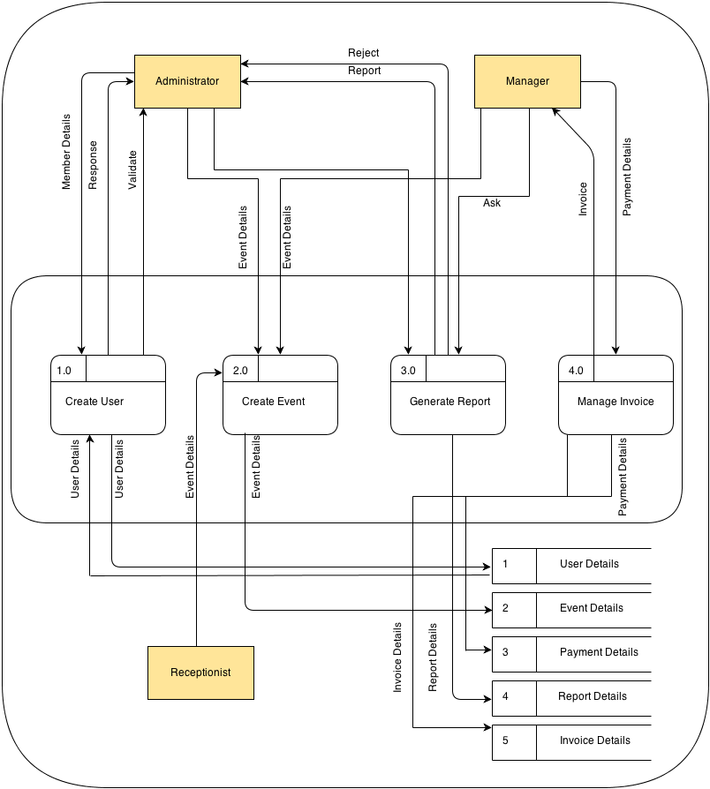

Figure 3.2 – 1st level Data Flow Diagram

All the related decision tables for this data flow diagram are listed below.

Create User
User is employee | Y | Y | Y | Y | N | N | N | N
Previous account | Y | Y | N | N | Y | Y | N | N
National ID Card | Y | N | Y | N | Y | N | Y | N
Create User |  |  | X

Table 3.1 – Decision Table for Create User

Create Event
User logged in | Y | Y | Y | Y | N | N | N | N
Previous event | Y | Y | N | N | Y | Y | N | N
Payment | Y | N | Y | N | Y | N | Y | N
Create Event |  |  | X

Table 3.2 – Decision Table for Create User

Generate Report
User logged in | Y | Y | Y | Y | N | N | N | N
Report type availability | Y | Y | N | N | Y | Y | N | N
Criteria correct | Y | N | Y | N | Y | N | Y | N
Generate Report | X

Table 3.3 – Decision Table for Generate Report

Manage Invoice
User logged in | Y | Y | Y | Y | N | N | N | N
Correct payment details | Y | Y | N | N | Y | Y | N | N
Invoice format correct | Y | N | Y | N | Y | N | Y | N
Manage Invoice | X

Table 3.4 – Decision Table for Manage Invoice

3.3.3 Class Diagram.

In software engineering, a class diagram in the Unified Modelling Language (UML) is a type of static structure diagram that describes the structure of a system by showing the system’s classes, their attributes, operations (or methods), and the relationships among the classes.

The class diagram is the main building block of object oriented modelling. It is used both for general conceptual modelling of the systematics of the application, and for detailed modelling translating the models into programming code. Class diagrams can be used for data modelling. The classes in a class diagram represent both the main objects, interactions in the application and the classes to be programmed [WWW2].

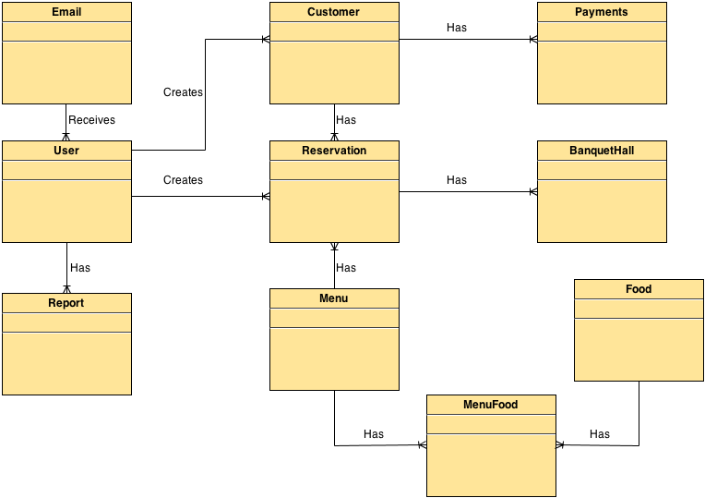

Figure 3.3 – Class Diagram

The above diagram illustrates the class diagram of the event management system. Main there are 10 classes named, Use, Customer, Report, Email, Reservation, Menu, Food, MenuFood, Payment, BanquetHall.

3.3.4 State Diagram.
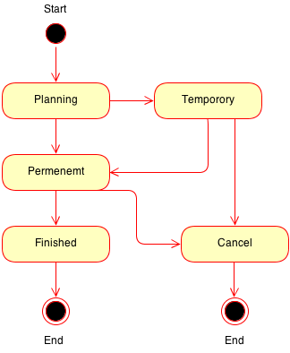

Figure 3.4 – State Diagram for Event

A state diagram is a type of diagram used in computer science and related fields to describe the behaviour of system. The above diagram illustrates the state diagram for the event. It shows the possible states that a particular event can be.

References

[www1] - Wikipedia web site (Non-functional requirements) [04-04-2013]
http://en.wikipedia.org/wiki/Non-functional_requirement

[WWW2] – Wikipedia web site (State Diagram) [15-04-2013]
http://en.wikipedia.org/wiki/Class_diagram

